**PIZZA SALES SQL QUEREIS**

1. **KPI’S**
2. Total Revenue:

SELECT SUM(total_price) as Total_revenue from pizza_sales

**Output:**

1. Average Order Value

select sum(total_price) / count(distinct order_id) as Avg_Order_Value from pizza_sales

**Output:**

1. Total pizza sold

select sum(quantity) as total_pizza_sold from pizza_sales

**Output:**

1. Total order

select count(distinct order_id) as total_order from pizza_sales

**Output:**

1. Average Pizza Per Order

select cast(cast(sum(quantity) as decimal (10,2)) /

cast(count(distinct order_id)as decimal (10,2)) as decimal (10,2)) as Avg_pizza_per_order from pizza_sales

**Output:**

1. Daily Trend For Total Order

select datename(dw, order_date) as order_day, count(distinct order_id) as total_orders from pizza_sales

by datename(dw, order_date)

**Output:**

1. Hourly Trend Total Orders

select datename(month, order_date) as month_name, count(distinct order_id) as total_orders from pizza_sales

group by datename(month, order_date) order by total_orders desc

**Output:**

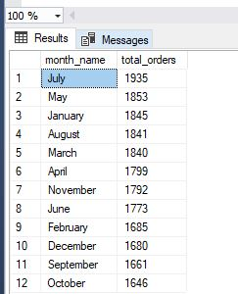

1. Percentage of Sales by Pizza Categary:

select pizza_category ,sum(total_price) as total_sales, sum(total_price) *

(select sum(total_price) from pizza_sales

where month(order_date) =1) as pct

from pizza_sales where month(order_date) =1 group by pizza_category

**Output:**

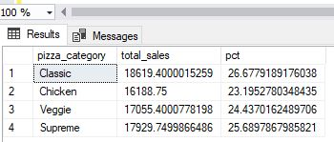

1. Top 5 Pizza by Revenue

select top 5 pizza_name, sum(total_price) as Total_revenue from pizza_sales

group by pizza_name order by Total_revenue desc

**Output:**

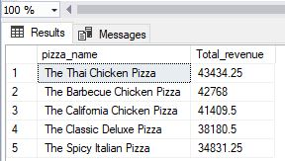

1. Bottom 5 pizza by revenue

select top 5 pizza_name, sum(total_price) as Total_revenue from pizza_sales

group by pizza_name order by Total_revenue asc

**Output:**

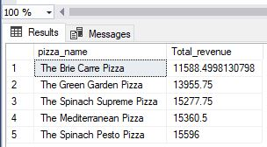

1. Top 5 pizza quantity

select top 5 pizza_name, sum(quantity) as Total_quantity from pizza_sales

group by pizza_name order by Total_quantity desc

**Output:**

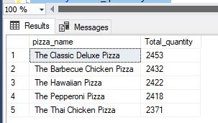

1. Bottom 5 pizza quantity

select top 5 pizza_name, sum(quantity) as Total_quantity from pizza_sales

group by pizza_name order by Total_quantity asc

**Output:**

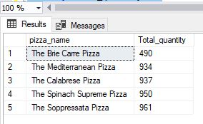

1. Top 5 pizza count

select top 5 pizza_name, count(distinct order_id) as Total_orders from pizza_sales

group by pizza_name order by Total_orders desc

**Output:**

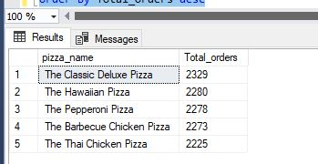

1. Bottom 5 counts

select top 5 pizza_name, count(distinct order_id) as Total_orders from pizza_sales

group by pizza_name order by Total_orders asc

**Output:**

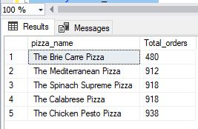

select * from pizza_sales

select sum(total_price) / count(distinct order_id) as Avg_Order_Value from pizza_sales

select sum(quantity) as total_pizza_sold from pizza_sales

select count(distinct order_id) as total_order from pizza_sales

select cast(cast(sum(quantity) as decimal (10,2)) /

cast(count(distinct order_id)as decimal (10,2)) as decimal (10,2)) as Avg_pizza_per_order from pizza_sales

select datename(dw, order_date) as order_day, count(distinct order_id) as total_orders

from pizza_sales

group by datename(dw, order_date)

select datename(month, order_date) as month_name, count(distinct order_id) as total_orders

from pizza_sales

group by datename(month, order_date)

order by total_orders desc

select pizza_category ,sum(total_price) as total_sales, sum(total_price) * 100 / (select sum(total_price) from pizza_sales

where month(order_date) =1) as pct

from pizza_sales

where month(order_date) =1

group by pizza_category

select pizza_size, cast(sum(total_price) as decimal(10,2) as Total_sales, cast(sum(total_price)

(select sum(total_price) from pizza_sales where datepart(quarter, order_date )=1) as decimal(10,2))

from pizza_sales

where datepart(quarter, order_date) = 1

group by pizza_size

order by pct desc

select top 5 pizza_name, sum(total_price) as Total_revenue from pizza_sales

group by pizza_name

order by Total_revenue asc

select top 5 pizza_name, sum(quantity) as Total_quantity from pizza_sales

group by pizza_name

order by Total_quantity desc

select top 5 pizza_name, sum(quantity) as Total_quantity from pizza_sales

group by pizza_name

order by Total_quantity asc

select top 5 pizza_name, count(distinct order_id) as Total_orders from pizza_sales

group by pizza_name

order by Total_orders desc

select top 5 pizza_name, count(distinct order_id) as Total_orders from pizza_sales

group by pizza_name

order by Total_orders asc